Task related to ECS.

- Setup a highly available ECS cluster with load balancer and dynamic port mapping.
NOTE:
Your cluster should maintain at least 6 tasks at any point of time and should be highly available across multiple AZ's.
Use the below image from deployment:
sabair0509/hiring-app: works

Today's task — architecture
Application Load Balancer
Receives and distributes web traffic
Availability Zone A
ECS EC2 instance(s)
Tasks 1, 2, 3…
Availability Zone B
ECS EC2 instance(s)
Tasks 4, 5, 6…
The ALB routes requests to healthy tasks using dynamically assigned host ports.

ECS Task: Highly Available Cluster with ALB and Dynamic Port Mapping
Objective: Deploy sabair0509/hiring-app:works on Amazon ECS, maintain at least six running tasks across multiple Availability Zones, and expose the application through an Application Load Balancer (ALB).
Traffic flow: Browser → ALB port 80 → Target group → ECS instances dynamically assigned host port → Container port 8080 → Hiring application.
2. Step-by-step implementation
Step 1: Create the ECS cluster
- Open AWS Console → ECS → Clusters → Create cluster.
- Enter cluster name: hiring-ecs-cluster.
- Configure the EC2 infrastructure using the ECS capacity provider / Auto Scaling group setup.
- Select the VPC majeed-vpc and subnets in two Availability Zones.
- Configure the Auto Scaling group with:
  - Minimum capacity: 2
  - Desired capacity: 2
  - Maximum capacity: 5
- Create the cluster and wait for the container instances to register.
Note: An ECS cluster is a logical grouping of resources used to run and manage containerized applications. Multiple Availability Zones improve availability if one zone experiences a problem.
Step 2: Create the task definition
Navigate to ECS → Task definitions → Create new task definition.
Use these settings:
Setting | Value
Family | hiring-app-task
Launch environment | EC2
Network mode | bridge
CPU | 256
Memory | 512 MiB
Container name | hiring-app
Image | sabair0509/hiring-app:works
Container port | 8080
Host port | 0
Protocol | TCP
Execution role | ecsTaskExecutionRole
Configure CloudWatch logging:
Setting | Value
Log driver | awslogs
Log group | /ecs/hiring-app-task
Region | us-east-1
Stream prefix | ecs
Create the task definition.
Important concept — dynamic port mapping: Setting hostPort: 0 allows ECS/Docker to assign an available host port dynamically for each task. Multiple tasks can run on the same EC2 instance without requiring the same host port.
Step 3: Configure the security groups
We used two security groups:
- ALB security group — hiring-alb-sg: Allows inbound HTTP traffic on port 80 from 0.0.0.0/0.
- ECS instance security group — ecs-cluster-sg: Allows the dynamic port range 32768–60999 from the VPC CIDR 10.0.0.0/16.
Why? The ALB receives browser requests on port 80. The ECS instances must allow traffic to the dynamically assigned host ports.
For production, restrict the ECS dynamic-port inbound rule to the ALB security group rather than the entire VPC CIDR where possible.
Step 4: Create the target group
Navigate to EC2 → Target Groups → Create target group.
Configure:
Setting | Value
Name | hiring-app-tg
Target type | Instances
Protocol | HTTP
Port | 80
VPC | majeed-vpc
Health check path | /hiring
Success codes | 200-302
Other health-check settings:
- Healthy threshold: 5
- Unhealthy threshold: 2
- Timeout: 5 seconds
- Interval: 30 seconds
Why? The target group tracks the ECS instance and dynamically assigned host-port combinations, then checks whether the application responds.
We initially used /, which returned 404. The Tomcat logs showed that hiring.war deployed at /hiring. The application then returned 302, so we changed the success-code matcher to 200-302.
Production note: Accepting 302 marks redirects as healthy but doesn't guarantee the final destination is working. A dedicated health endpoint returning 200 is preferable.
Step 5: Create the Application Load Balancer
Navigate to EC2 → Load Balancers → Create load balancer → Application Load Balancer.
Configure:
Setting | Value
Name | hiring-app-alb
Scheme | Internet-facing
IP address type | IPv4
VPC | majeed-vpc
Availability Zones | us-east-1a and us-east-1b
Listener | HTTP : 80
Default action | Forward to hiring-app-tg
Attach the ALB security group hiring-alb-sg.
Why? The ALB provides a single public entry point and distributes incoming HTTP requests to registered targets.
Step 6: Create the ECS service
Navigate to ECS → Clusters → hiring-ecs-cluster → Create service.
Configure:
Setting | Value
Service name | hiring-app-task-service-chscdgqo
Task definition | hiring-app-task:1
Scheduling strategy | Replica
Desired tasks | 6
Load balancer | hiring-app-alb
Listener | HTTP : 80
Target group | hiring-app-tg
Health check grace period | 60 seconds
Availability Zone rebalancing | Enabled
Create the service and allow ECS to start the tasks.
Why? The ECS service maintains the desired number of tasks, replaces failed tasks, and registers and deregisters task targets with the ALB.
Step 7: Verify dynamic port mapping
Open ECS → Cluster → Tasks → select a running task → Container details.
Confirm the task definition has:
- Container port: 8080
- Host port: 0
- Network mode: bridge
In EC2 → Target Groups → hiring-app-tg → Targets, we saw dynamically assigned ports such as 32774, 32775, and 32776.
This confirms that the application container's port 8080 is mapped to dynamically assigned host ports.
Step 8: Troubleshoot the failed health checks
Initially, the ALB target group reported 404 and later 302.
We resolved the health-check issue as follows:
- Opened CloudWatch → Log groups → /ecs/hiring-app-task.
- Checked the Tomcat startup logs.
- Found the deployment path /usr/local/tomcat/webapps/hiring.war.
- Changed the health-check path from / to /hiring.
- Changed the success codes from 200 to 200-302.
- Saved the settings and refreshed the target group.
The target group then showed 6 healthy targets and 0 unhealthy targets.
The earlier ECS deployment also showed Rollback failed. We verified the health checks and started a fresh deployment using the existing task definition. The service overview subsequently showed Deployment status: Success.
Step 9: Test the application
Open the ALB DNS address:
Open the Hiring App
We saw:
Welcome to Techie Horizon
This confirmed that the application was accessible through the ALB.
3. Final verification checklist
Use this checklist when repeating the lab or presenting your work.
Task completion checklist
9 of 9
ECS cluster is active
hiring-ecs-cluster
Correct Docker image configured
sabair0509/hiring-app:works
Task definition uses dynamic port mapping
containerPort 8080, hostPort 0
ALB listener forwards HTTP traffic
Port 80 → hiring-app-tg
At least six tasks are running
Desired 6, running 6
Tasks run across multiple Availability Zones
us-east-1a and us-east-1b
Target group has healthy targets
6 healthy targets
Application works through the ALB
Welcome to Techie Horizon
Latest service deployment succeeded
Deployment status: Success
4. Important interview notes
Question | Simple answer
What is Amazon ECS? | A service for running and managing containerized applications.
What is an ECS task definition? | A blueprint that specifies the container image, ports, CPU, memory, and logging.
What is an ECS service? | It maintains the desired number of running tasks.
What is an ALB? | A Layer 7 load balancer that distributes HTTP/HTTPS traffic.
What is dynamic port mapping? | The host port is assigned dynamically so multiple containers can use the same container port on one instance.
Why use multiple AZs? | To improve availability and reduce dependence on a single Availability Zone.
What is a target group? | It registers targets and performs health checks before routing traffic to healthy targets.
What is CloudWatch logging used for? | To inspect container startup messages, errors, and application behavior.
Why did the health check initially fail? | / returned 404; the application was deployed at /hiring and returned a redirect.
What does desired count 6 mean? | ECS attempts to maintain six running tasks.
Final result: Your reported service state was Active, with six desired and running tasks, six healthy targets, a working ALB URL, and a successful latest deployment. The assignment is complete based on those results.

Error: No Ec2 instances were launce this is an error after creating cluster:
We found the problem. The EC2 instances failed to launch because t3.medium is not eligible for the Free Tier under the account's current eligibility rules.
Fix the issue by changing instance type:
You're on the correct launch template page. The existing template is still Version 1 with t3.medium, so the change to c7i-flex.large has not been saved yet.
Step 1 — Open the correct Actions menu
On this page, you may see two Actions menus:
- The upper one next to the launch template name.
- The lower one next to Launch template version details.
Click the upper Actions menu next to the launch template name, then select Modify template (Create new version).

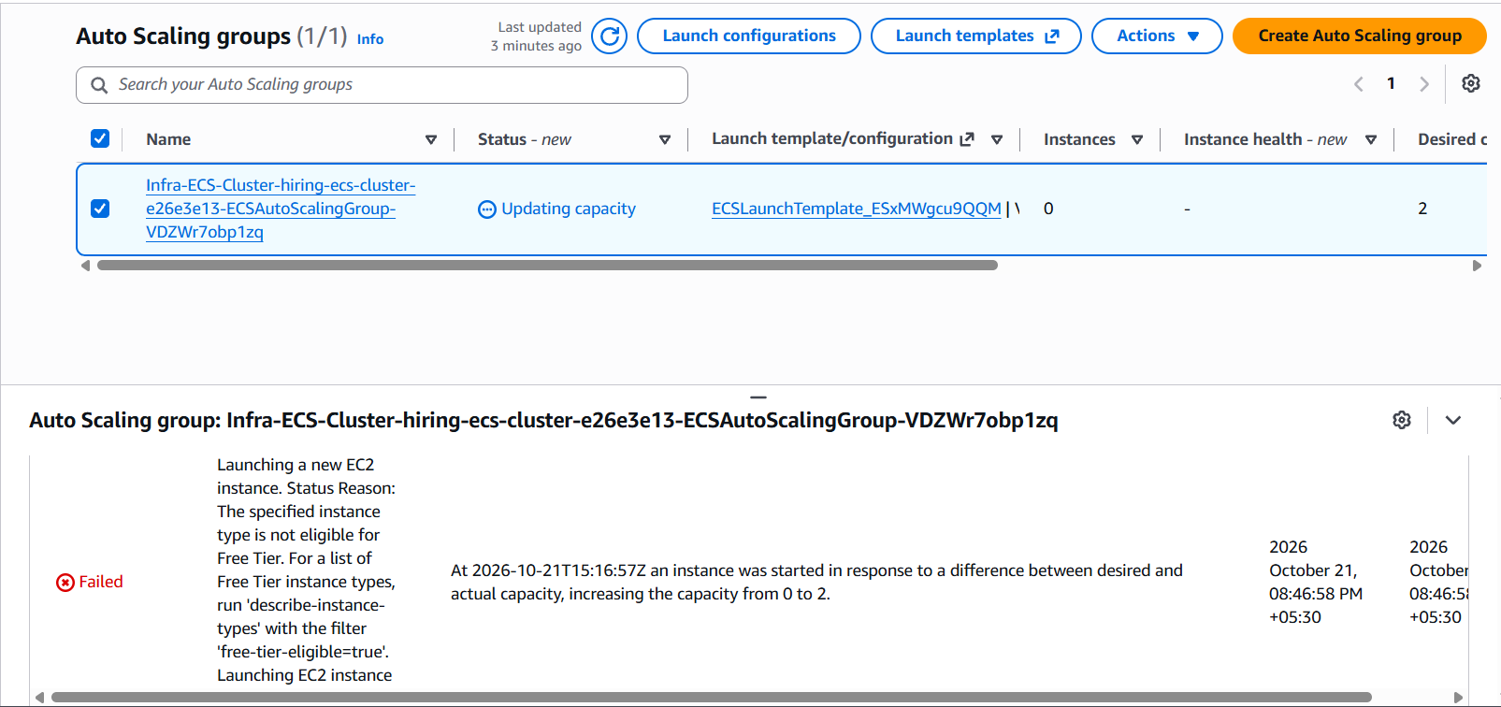
Two instances:
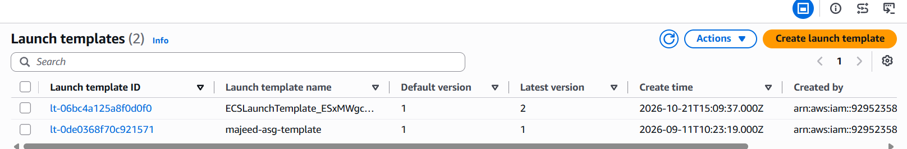
Edit in autoscaling group also
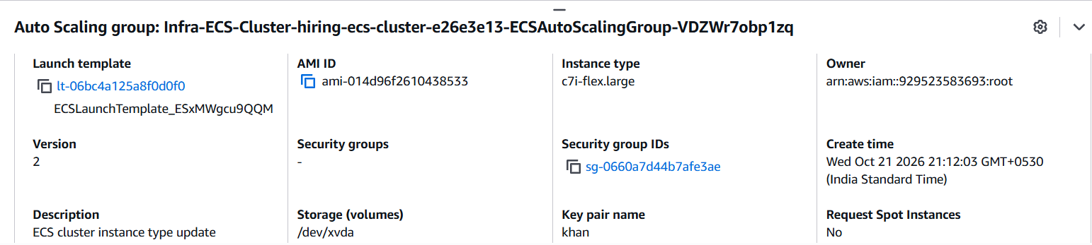
Activity history
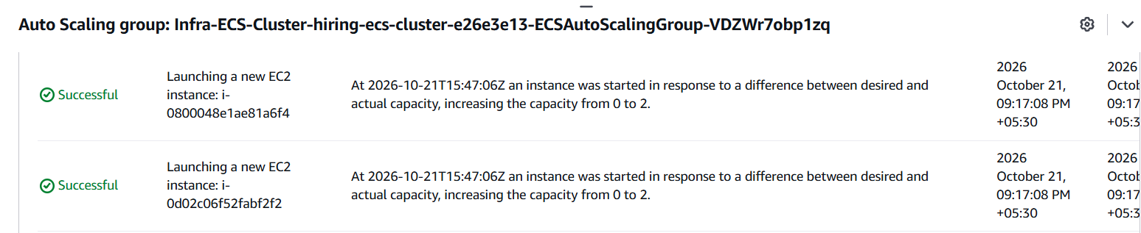
ECS cluster is ready.
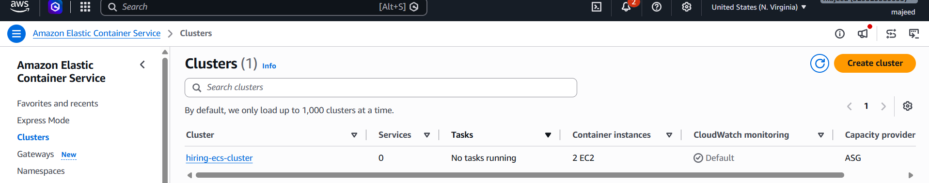
Creating Definition:
Why Host port = 0?
ECS dynamically assigns an available host port to each task. The ALB can then route requests to the correct task, even when multiple tasks run on the same EC2 instance.
Important: 8080 is only correct if this image listens on port 8080. If the task definition or app documentation specifies a different port, use that port instead.

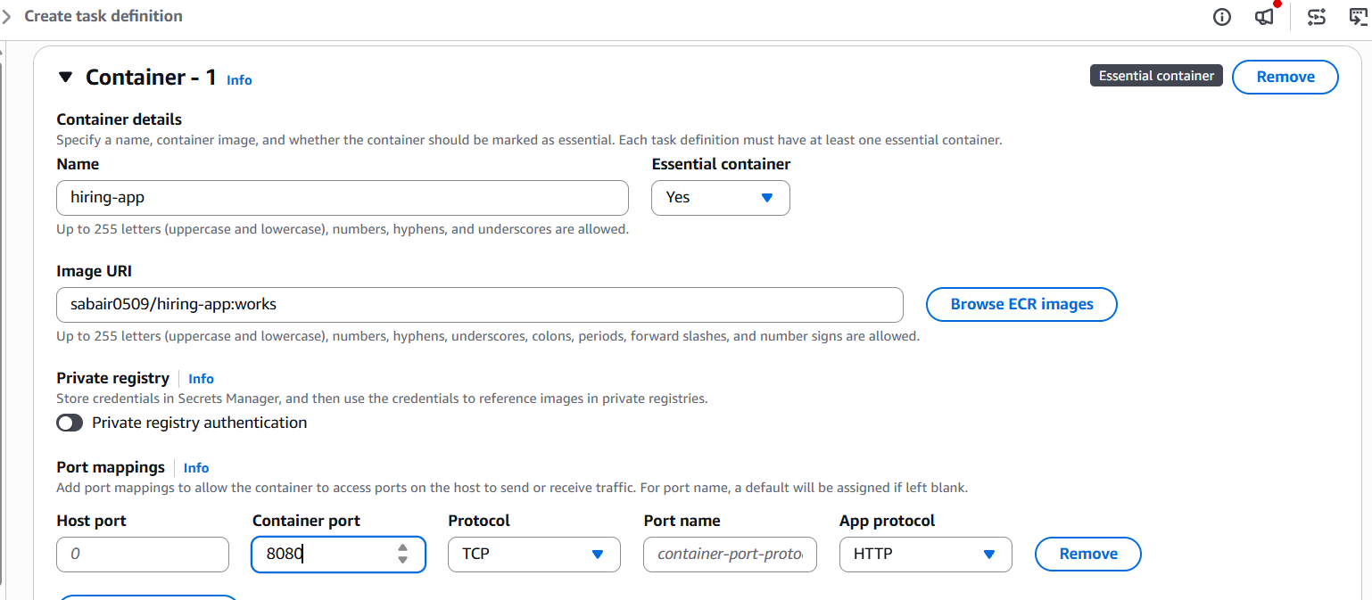
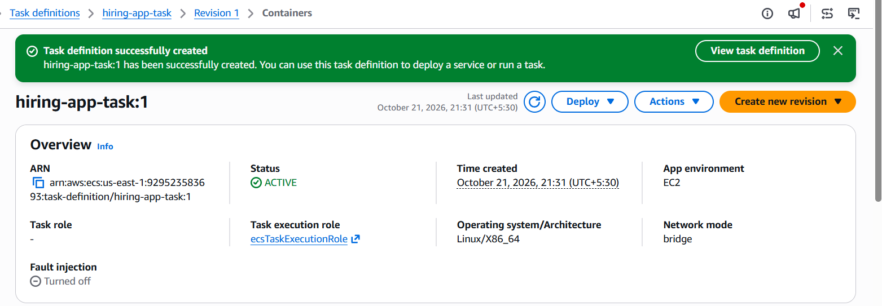
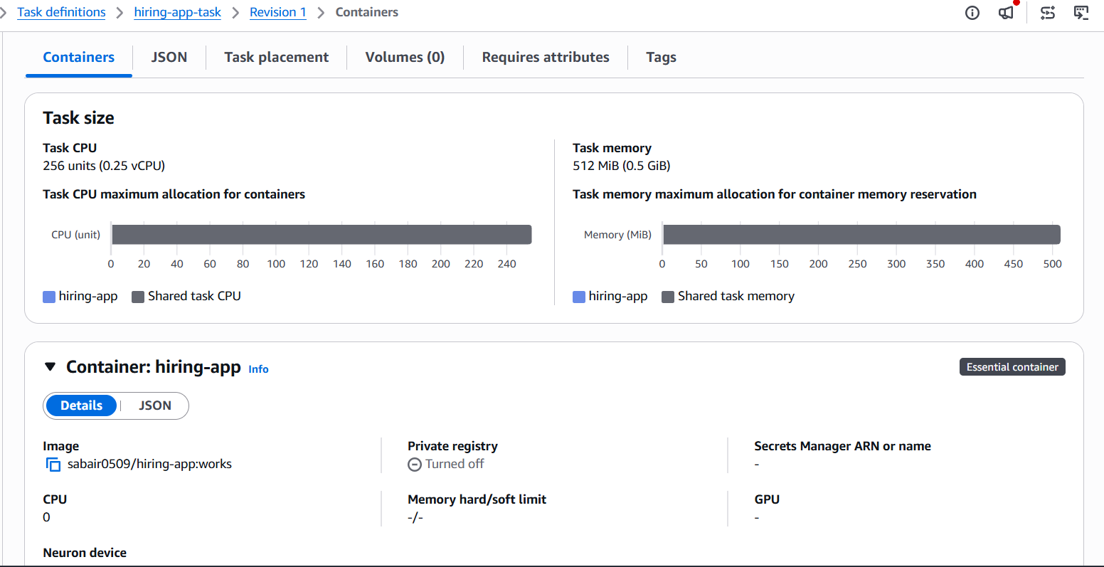
Deployment configuration
- Deployment type: Replica
Why? Replica lets ECS maintain a specified number of copies of your application. Your assignment requires at least 6 running tasks.
Step 1: Create the target group
Click Create target group.
Configure it as follows:
Setting | Value
Target type | Instances
Target group name | hiring-app-tg
Protocol | HTTP
Port | 80
VPC | majeed-vpc (vpc-0a7c7aaf297ccd03c)
Protocol version | HTTP1
Why target type Instances? Your ECS tasks use bridge networking with host port 0. ECS registers the EC2 instance together with each task's dynamically assigned host port.

Created Load balancer
